

**Register of Interests**

|  |  |  |  |  |  |  |  |
| --- | --- | --- | --- | --- | --- | --- | --- |
| **Name** | **Position** | **Name of organisation** | **Nature of interest** | **Date interest was registered** | **Date interest ceased** | **Notes** | **Relationships within school** |
| Mike Pride | Executive Headteacher |  |  |  |  | Governor at Corfield Infant School from September 2018 | N/A |
| Sandra Fletcher | Chair of Governors | *Educational Consultant | Governance support and training |  |  | Governor at Chellaston Academy from May 2020 | N/A |
| Kat Pilling | Governor |  |  | N/A | N/A |  | N/A |
| Jemma Tague  (Newtons Walk) | Staff Governor |  |  | N/A | N/A |  | N/A |
| Jade Murden | Governor |  |  | N/A | N/A |  | N/A |
| Will Broderick  (Kingsmead) | Staff Governor |  |  | N/A | N/A |  | N/A |
| John Boyle | Governor |  |  | N/A | N/A |  | N/A |
| Cecilia Emery | Governor | *Education Business Support Consultation | HR and Policy advice |  |  |  | N/A |
| Deborah Robinson | LA Governor |  |  | N/A | N/A | Governor at Chellaston Academy from  1 June 2021 | N/A |
| Kieran Dwyer | Governor |  |  | N/A | N/A | Governor at Roe Farm Primary School from September 2019 | N/A |
| Lia Copestake | Associate Member |  |  |  |  |  | N/A |
| Emmet Bunting | Associate Member |  |  |  |  |  | N/A |

**\*The school may choose to buy into these services**

**Record of Review** (review to be conducted by the clerk)

Date: 8 September 2021

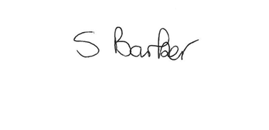

Signature:

Updated April 21